**SUPPORT TO VET REFORMS IN UZBEKISTAN (VET4UZ)**

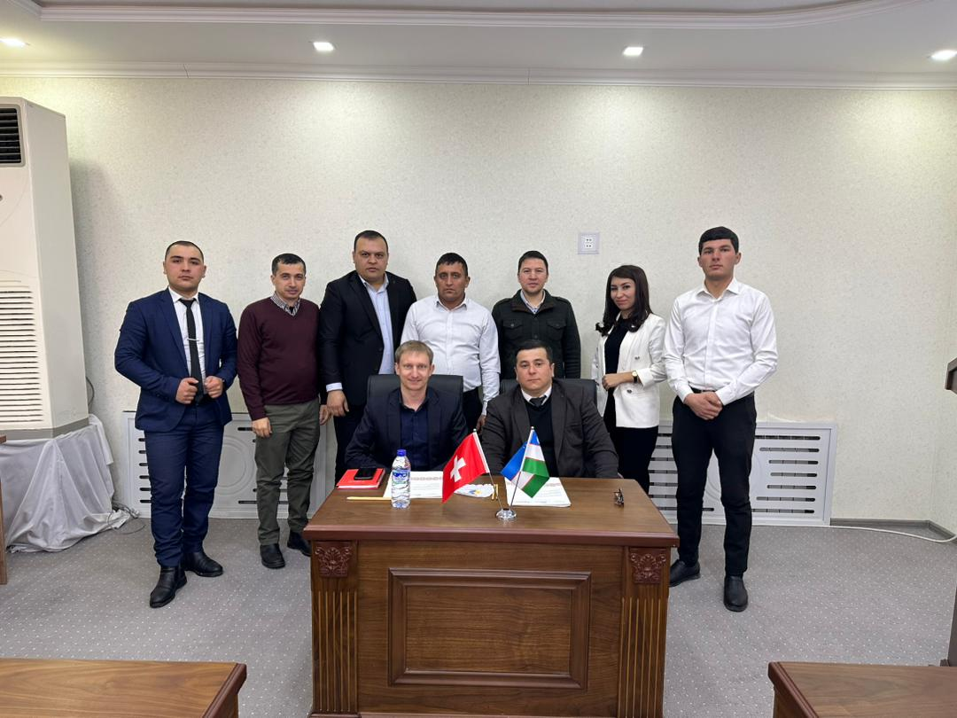

Private sector needs assessment – Skills gap analysis of the hospitality sector

Tashkent/Bern, 20th February 2023

Authors: Adrien Rebord, Asliddin Odilov, Sardor Saidrasulov

Introduction

## Project background

Uzbekistan is undergoing a transformation from a public sector-dominated to a private sector-dominated economy. There is still a prevailing proportion of large state-owned companies compared to the fast-rising number of privately owned small and medium-sized businesses.

The main goal of VET4UZ (Phase I) is to contribute to more gainful employment of VET graduates through improved access to the labour market. This will be achieved through a systemic approach fostering improved coordination within the state structures as well as between the state and the economic actors and the improvement of quality of inputs (profiles, curricula, learning material, infrastructure, financing) into the VET offer.

The hospitality sector and three target regions (Bukhara, Jizzakh and Bustanlik) have been selected to conduct pilot interventions and create evidence for improved decision making for the development of the VET system.

## Objectives of the mission

The objectives of the mission were to :

1. Provide backstopping support to VET4UZ team on the project progress;
2. Visit pilot VET providers in the pilot regions and identify capacity building needs;
3. Establish opportunity to engage employers in the selected regions.

As a complement, the analysis below defines the main skills mismatch in the hospitality sector and potential entry points for VET4UZ in the selected regions.

## Methodology

The terms or reference and the mission planning are presented in Annexe 3. Data collection focused on bilateral interviews, on-site visits and exchanges with the project team. It included school analysis and private sector needs assessment based on the following questionnaires provided by the Ecole hôtelière de Lausanne (EHL).

 

National level: hospitality training in Uzbekistan

## Hospitality sector in Uzbekistan

In Uzbekistan, **the hotel industry is booming** but new and existing units have difficulties to meet the rising demand for quality services. There is limited qualified staff available in the market contrasting with a substantial growth of youth unemployment. As the number of recent graduates is not sufficient for the market and newly recruited employees are not up to the standards, problems arise to fit the future needs of visiting tourists.

According to a survey of the Hoteliers Association of Uzbekistan (November 2022), **more than 800 new hotels, both large and small, have been commissioned in Uzbekistan** over the last 4 years. The total number of hotels today is about 1,500 with 39,400 rooms and 81,200 beds. Hundreds of new hotel projects are currently under construction and will be commissioned in the near future. This growth is driven by very favourable business condition stimulating local investments.

While supply is flourishing, demand has already recovered. Statistics shows that 3.6 million foreign visitors visited Uzbekistan for tourism purposes in the first half of 2022. Examination of hotel occupancy in the Republic of Uzbekistan of all categories in March 2022 **exceeded pre-pandemic levels**. Furthermore, there was an influx of tourists and relocators from the Russian Federation, increased cyclical migration of Uzbek nationals, and the return of migrant workers to the country under the influence of the pandemic.

Uzbek Government, which brings an important focus on tourism development, recognises the importance of vocational education for improving service in the tourism and hospitality sector. Meetings with two national actors, the Ministry of Tourism and the Hoteliers Association, confirmed that existing tourism and **hospitality education offer lack practice and market relevance**. This can be compensated by the various government initiatives (e.g. Ministry of Tourism is supporting the process of developing standards and training manuals) and international (Swiss) expertise on the topic.

The hotel association, as well as General Managers and key staff of hotels visited, have large experience and deep understanding of hospitality staff management and development. The quality issue rather lies in the baseline staff that is not sufficient to meet the growing needs. Most of the 100 affiliated **hotels of the association need to conduct in-house training despite the tread of staff turnover** deepened by new openings.

Few companies have the idea to open their own training centers and to work on standards for hotels. From a dual VET perspective, such initiatives are rather positive to increase the capacity of the industry to deliver training. Private training centers often focus more on upskilling and are not contradictory to formal dual VET but rather complementary. They support the development of standards and raise the overall level of service excellence with a bottom up approach. H**igher capacities of hotels can then benefit on-the-job training, initial training and the absorption of entry-level staff.** VET4UZ has a similar vision aiming to pilot with one or few leading hotels in each region.

## A sector adapted to pilot dual VET

**Why does VET4UZ pilot dual VET at regional level?** The main objective of working with schools and employers in three different regions is to gather evidence **to inform decisions of the Ministry about the reform and improve the overall VET system**. Differences among the regions will bring important learning and underline which features might work in a region but not another, and why.

Based on the data gathered and previous experiences of applying dual VET, the hospitality sector represents the best choice for piloting. Amongst other for the following reasons:

* **Demand:** there is a huge demand from the labour-market which is ready to make the required efforts to contribute to training. The important job prospects are also crucial from a government and youth perspective;
* **Attractiveness**: although some jobs have lower status (e.g. housekeeping), there is no important obstacle to student enrolment. The sector is rather seen positively by youth and their families;
* **Inclusiveness:** data collection confirms that the sector is very inclusive as most of the hotels have more than 50% of women with specific conditions for them. They employ youth from all ethnicities including some with low education background or from poor families;
* **Availability and capacities of employers**: many hotels have in-house expertise, internal training, human resources departments and Standards Operating Procedures (SOPs). Smaller units have fewer staff but also the capacity to train interns properly;
* **Possibility of scaling up and institutionalisation**: the hospitality sector has a great combination of hard skills but also soft skills which makes the best practices developed easily transferable for other sectors. Hospitality ventures are present throughout the country (e.g. Samarkand, Tashkent) which facilitate upscaling in a future phase.

Although it is not the primary goal of VET4UZ, exchanges with the Ministry of Tourism revealed that piloting with the hospitality sector can also support the development of the tourism industry by supplying hotels with more competent human resources and creating service excellence in Uzbekistan.

To avoid duplication, VET4UZ should pay particular attention to coordinate any initiative (curricula review, training material…) with the **Ministry of Tourism that is investing heavily in improving the sector.**

Main findings over the different regions

### Skills gap analysis

The below analysis cannot be exhaustive as it is based on a limited number of hotels interviewed but it is a good complement to the survey of enterprises and employers (hotels) on the quality of vocational education in Uzbekistan (November 2022).

Interviews revealed that there is a skills shortage at different levels (top management of small family-run and locally owned hotels, middle management and especially entry-level staff), for the different hospitality ventures (hotels, restaurants, guesthouses) and regarding the different profiles of employees (age, localization, local/foreign experience, with/without hospitality education).

New hotels are opening resulting in **an important pressure on a restricted pool of highly skilled workforce**. There are limited qualified staffs available in the market contrasting with a substantial growth of job offer in the country. This lack of qualified professionals is a threat to the development of the sector.

Considering the sector globally, it is therefore crucial to respond to the requirements of the hotels as well as smaller ventures. **Across the various types of hospitality businesses important skills gap have been identified at all levels and in both, hard and soft skills.**

1. **Hard skills in the four main hospitality jobs**

As detailed further below under the analysis of the training offer, students are rather **trained in schools on the theory side only and as generalists** (hotel administration, hotel management). Many hotel were rather critical about few graduates explaining that “*they don’t know how to work*”, “*they know only the theory*” or “*we have to retrain everything*”.

Whereas overall knowledge is sufficient for small hotels, larger and upscale units are in high demand of specialists and would like to have youth trained in one or two of the main departments:

1. Reception / front office
2. Housekeeping / room attendant
3. Kitchen / cook
4. Waiter / F&B service
5. **Hospitality soft skills**

Hospitality soft skills can include a wide variety of topics but are not technical or administrative competencies. They are not required to perform the routine tasks associated with the position but rather **transversal to be applied to various hospitality jobs** such as the one required to interact with guests or with other staff members, how to plan and organize work, manage time, act responsibly or manage others. Schools are not the best placed to learn soft skills which are acquired through on-the-job training (OJT).

In the case of Uzbekistan, hospitality soft skills gap identified embraces:

1. **interpersonal skills** such as communication (with guest, within staff and with supervisor), human resources management, cultural awareness, teamwork;
2. **operational soft skills** such as leadership, pro-activity, initiative taking, critical thinking, creativity or problem-solving mindset;
3. **socio-professional skills** such as attitude at work, behaviour, grooming, hygiene, punctuality, informing when absent or when making a mistake;
4. **customer service:** according to industry professionals, “*service is everything*” but hospitality graduates lack customer orientation at work. Although very present in the Uzbek culture, the hospitality mindset is not fully integrated through programs and within small business. Hotel managers revealed that most of the staff having a good understanding of customer service had worked abroad or in luxury hotels previously.

Whereas the three first types of soft skills mainly need to be acquired during internships (or OJT), the fourth (customer service and hospitality culture) needs a complete mentality development from the start, including from school culture. Presently, **there is no “hospitality culture” in these schools** that do not have a full focus on hospitality, nor teachers with experience in international hotel chains.

Service excellence in Uzbekistan

The Uzbek Railway [www.railway.uz](http://www.railway.uz) is a good example of service excellence that the hospitality sector should aim at. Having their own training center, they build capacities of their staff (controllers and service staff) on customer service. Passengers can notice professional service from train attendant including important aspects such as punctuality, rigor, precision, grooming, language skills and customer orientation.



There is a need to embed service excellence within the school culture to support courses such as customer relation, guest satisfaction or customer recovery, which are crucial to learn **how to anticipate client’s needs and take initiatives to provide a tailored service**. Such training should include an understanding of cultural differences and intensive role plays to learn through simulated exercises. Training topics can contain guest welcoming, creating a good first impression, handling guests’ requests and complains, active listening, communication or creating guest’s experience.

1. **Other key points contributing to skills gap**

In addition of the two main skill groups presented above, hotels and restaurants managers interrogated during the training needs assessment reported unequivocally that:

* language skills, especially Russian, are highly desired in emerging destination such as Zaamin and Bustanlik;
* staff turnover is very high in Uzbekistan and workforce development should be supported by proper HR development and contracts;
* qualified employees tend to look for jobs abroad, especially Russia or Turkey, to earn better salaries. Some employees who returned to Uzbekistan in 2022 explained that they were earning five times more in Moscow ;
* there is a better hospitality mindset and understanding of customer expectations from the employees having work experience abroad (Turkey, Cyprus, Russia, Almaty);
* educational attainment (school certificate) does not play a decisive role in employers’ recruitment policy which prioritize work experience and attitude because “hard skills can be more easily trained”;
* cooperation with education institutions is currently limited to internships.

The symptoms identified in the skills gap analysis translate a clear lack of interaction between the private sector and academia which has been confirmed by stakeholders and secondary data. Mismatch result predominately from a **supply-driven orientation to skills development, weak linkages between education institutions and the labor market, and obsolete education standards and curricula (which are not based on occupational and functional analyses).** This calls for a better involvement of hotels in the curriculum design, more local practical experience from the hospitality instructors and more on-the-job training within training programs.

### Teachers/trainers

Discussions were held with the teachers of the different pilot institutions to understand their background and capacity building needs. At the same time employers were consulted about competencies of fresh graduates.

The main conclusion is that **teachers deeply lack professional experience in the industry**. This result in an absence of understanding of operational processes and standards applied in hotels and other tourism ventures. From a capacity development perspective, it seems very difficult to retrain these teachers as **the main gap is related to work experience** which is required to link the theory they deliver with real-life situation in hotels.

The teachers needs assessment conducted by VET4UZ highlights the necessity for continuous professional development of new competencies of managers and teachers to ensure their effectiveness with the new VET system. Based on the principle of "lifelong learning", the report recommends retraining and professional development system for managers and teachers of VET institutions in Uzbekistan. **This recommendation is valid at national (system)** level though the Institute of Pedagogical Innovation for topics such as pedagogy, VET public policy, VET fundamentals, or managerial professional activities. However, **it cannot fill the skills gap at regional level** as it does not include hard skills, which are required for better market orientation.

If it is evident that the majority of VET teachers need additional professional development in the competencies that are in demand such as managerial, pedagogical, communicative, ICT and critical thinking skills. Such retraining is required to improve teaching but such t**hese competencies cannot close the “hard skills” gap to satisfy employers.**

As the teachers needs assessment underlines, **current teachers are not professional in the field they are teaching** because work experience of managers and teachers is not required by law for all categories of the positions studied. At school level, rather than focusing on retraining teachers, we suggest VET4UZ **to work at policy level on redefining the profiles** (e.g. require a minimum of 5-10 year experience in hotel operations, including middle management level).

As a complement and in the meantime, some mitigation measures can be proposed such as regular internships of teachers in the industry, visiting lecturers from the industry and closer interaction with employers. As described further above about soft skills, the service excellence culture is missing. This must come from **the trainer who transmit its passion for hospitality** and narrate stories related to experience at the workplace to illustrate the theory.

Beyond the redefinition of VET teachers profiles, another obstacle has been identified to increase the number of experienced professionals participating to the training: **current VET teachers are very low.** If wages of teachers and other public institutions have been recently increased, VET teachers are left behind **jeopardizing the quality of the whole VET system and its development**. For instance, three teachers of Bustanlik College have left their job recently due to the better working conditions in the private sector. If schools want to attract hospitality professionals, higher salaries are required so that VET is in coherence with education sector and competitive with the industry.

As a summary, we recommend VET4UZ to support advocacy for competitive wages of VET teachers and encourage the review of the teacher profiles for VET institutions with the objective **to include a minimum work experience for the specific job-related courses they are training.**

### Attractiveness of hospitality vocational training

The main study program in pilot schools is called “hotel management and organization”, which is a very general term. In developing countries the term “hotel management” is used to make hospitality courses more attractive (i.e. to youth and their parents) but it can rarely lead to a management position just after school creating wrong expectations from the applicants and making them changing pathways after school. Youth having paid fees and spent two years studying are **not willing to start with entry-level positions available.**

This was confirmed by school directors who mentioned that only 50% of graduates (e.g. in Zaamin) work in hotels after training. Data collected through the different vocational training schools demonstrates that the demand for vocational training, and in particular hospitality training, is on hold due to the reform and lack of clarity about post-training opportunities.Youth are aware of opportunities of employment and self-employment but not always encouraged by their families to follow this career path. In Uzbekistan, **career orientation is often decided by parents who prefer higher education or white-collar jobs**. Hence, college is often a second choice for students mainly coming from the same region as the school location.

Bringing hospitality culture and soft skills in curricula to have hospitality excellence embedded in training delivery would also **increase the attractiveness of institutions and career pathways**.

### School infrastructures

The government of Uzbekistan is **heavily investing in renovating VET schools** as illustrated in the pictures below. Tremendous progress on construction has been observed in the last year with the objective of finalizing construction for the next intake (September 2023). This will reinforce the attractiveness of VET pathways towards youth.

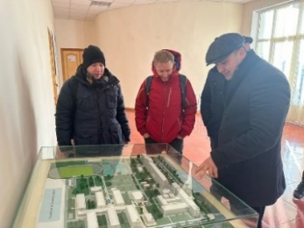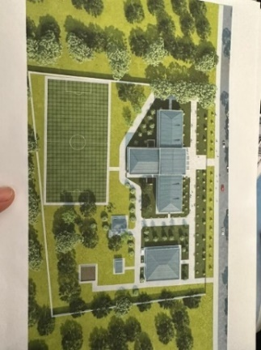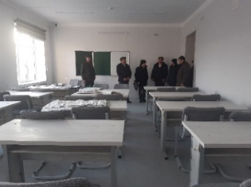

All schools have dormitories. They have been designed with theory classes (including digital connections) and labs (for practice). However, as infrastructure and equipment have been designed without reviewing curricula (or not even based on curricula), nor consulting employers, it is likely that **new investments will have little impact on improving the mismatch in skills development.**

Some recommendations have been made during the visits (e.g. having a housekeeping room sponsored by an international hotel group, using the school reception for real-life training in front office, having canteen/restaurant open to students/guest for practical training on-the-job…). Some Colleges (e.g. Bustanlik) are even considering PPP opportunities in expanding the services they provide. However, further support from the project (i.e. involving employers or after curricula adjustment) in reviewing equipment and training areas can help to improve market-relevance.

### Hospitality courses

The curriculum and study materials are obtained from Ministry of tourism (Institute of tourism development) and Ministry of Higher Education, Science and Innovation. The college teachers develop extra study materials but, according to school directors, they are not enough to train students on quality standards. The support from VET4UZ project to develop curricula and training materials would be very helpful.

Current courses per institution are presented in Annexe 1. Beyond the general name (Hotel management and organization), the sub-qualification are also general with “hotel administrator” or “manager of administrative and economic service”. Only Bukhara Technicum focuses on “Food & Beverage Manager” and Zaamin College has a “Room fund supervisor” course.

However, it is not possible to go further in the analysis without knowing more precisely the detail of these courses by **studying curricula and syllabi to understand technical topics taught. Nor it is possible to know how the practical courses are delivered without attending a practical class.** From the information we have, most of the courses focus on general theoretical knowledge (i.e. without real-life situation like role plays) and practice do not involve students (i.e. no individual practice in laboratory or training platform).

Institutions visited have the ambition to have innovative and context specific VET courses (horse riding, mountain guide with rock climbing) focusing on domestic tourism demand. The fact that these courses would be specific (training specialists) and focusing on domestic tourism is a first step in the right direction. However, **none of the colleges visited could present a real labour-market analysis to drive this change, nor a plan to restructure these courses**. So far, the review of curricula and course content mainly depend on central level (top-down approach) and is not enough tailored to regional needs of the employers.

Within the “dualization” of the hospitality courses, there is a need to review curricula to make them job related and competency-based (e.g. situation-based methodology from SFUVET or DACUM methodology). Here below is a presentation of the main hospitality courses offered by EHL worldwide. We can notice that it targets the four main hospitality professions (left part of the courses) being cook/chef (culinary), waiter (F&B service), receptionist and housekeeper (both in rooms division). In Uzbekistan, **courses offered start with hotel administration (middle management) as generalist and without training entry level staff (bottom-line)**. This is one of the cause of the skills gap together with the lack of practical on-the-job training.

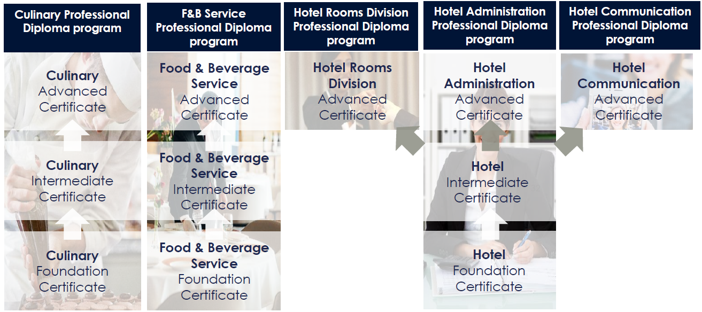

Exchange with the Bukhara State University (not part of pilot institutions) revealed that labor market needs are not studied to adapt course content, and the admission of new students is not entirely focused on employers’ needs. As such, many students with master's degrees continue their work at the University as teachers, **resulting in closed circle of knowledge without interaction with the industry.**

At college and technicum level, **the length of the courses is generally of 2 years (1 year and 3 months only for Bustanlik) which is well adapted and do not require modification.** For this level, the ideal duration should be 18-24 months that includes 9-12 month internship (starting with 6-9 month to better fit actual habits). As an example, we can see below how EHL adapted the Swiss dual training for hospitality by reducing its length from 36 to 18 months in order to apply it worldwide. As VET4UZ has a similar objective to “dualize” hospitality courses, this programme could serve as a basis and be adapted to the Uzbek context.

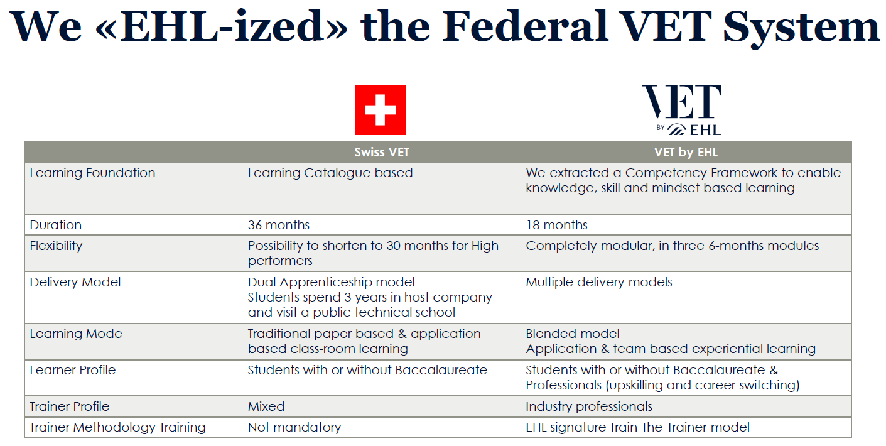

### Capacities of employers for on-the-job-training and cooperation with schools

Meeting with General Managers, human resource directors, owners and operators have been held in the different regions with the objective to get a feel of the hospitality and tourism market, specific talent development needs and potential contribution of the private sector. This was complemented by the visit of pilot colleges. Details about hotels and colleges visited are available in annexe 2.

The three regions and related schools visited are the following.

|  |  |  |  |
| --- | --- | --- | --- |
| **Region** | **Size km2** | **Population** | **Pilot school** |
| **Bukhara Region** | 41,937 | 1,843,500 | Bukhara Technikum of Tourism and Cultural Heritage |
| **Jizzakh Region** | 21,179 | 1,301,000 | Zaamin College of Service and Tourism |
| **Tashkent Region** | 15,258 | 2,424,100 | Bustanlik College of Tourism and Service |

In all regions, some common features have been noticed:

* **Main school challenges:** major challenges by colleges are the lack of proper infrastructure to train students, keeping teachers due to low salary, weak cooperation with the industry and organization of internships for students;
* **Schools infrastructures:** Schools will have the possibility to enroll between 150 and 600 students. All of them have a certain number of dormitories. However, infrastructure is not operational yet and should be completed for the next intake (September). Equipment is still to be analysed after construction is completed. Teaching process is organized in other buildings for this year;
* **Current cooperation between school and employers**: school cooperate with employers in the different regions (few large hotels and the rest are family hotels) to send students on internships. However, this dialogue is limited to the organization of internships and employers are not involved in school training delivery or conducting master classes. Most teachers do not have long-standing industry experience at operational level in hotels of the region which is an important cause of the skills gap;
* **Envisaged cooperation:** Employers are ready to regularly take interns and participate in skills development although the point out students motivation and socio-professional skills.

Colleges are considering more interactions with the industry but do not know how to do it. An opportunity is the vision of some colleges (e.g. Bustanlik) which intends to use the infrastructure as real training platform with guests (restaurant, school reception and rooms). Although this requires teachers with industry experience, it could be a first step to fill the skills gap underlined by employers;

* **Willingness to train from the hotels:** from hotels perspective, graduates know only the theory and practice (hard and soft skills) must be trained on-the-job. As many hotels are in remote locations (Zaamin and Bustalnik) and are in high demand for staff, they offer favorable working conditions for students who often get transportation, are provided with accommodation/food and even get paid during internship period. This, however, does not make them stay after internship due to distance, seasonality and interest for the job (lack of motivation);
* **High seasonality**: is the major challenges of hotels across all three regions visited. Although winter tourism has become popular in the last years, a destination like Zaamin is mainly used as a summertime zone. It hampers keeping qualified staff year-round and providing quality service on a long-term basis. Yet, from a dual VET perspective, it represents an opportunity as hotel require more workforce available in high-season which could be filled with by internships. More theory classes could then be delivered in low season;
* **Sector growth:** Many hotels are planned for construction in Bustanlik and Zaamin. New units are also expected in Bukhara. This secures job opportunities for college graduates but also increasing pressure on a limited pool of qualified professionals in the region. Although it makes the focus of the courses on tourism relevant, Bustanlik or Zaamin colleges alone will not be able to meet the demand for qualified labor which will also need to be recruited in other regions;
* **Employers capacity to contribute to training**: Most of small family-owned hotels do not have training manuals and SOPs to conduct on-the-job training despite a strong motivation to train youth. On the other side, most international, and several national, hotels have both capacity and motivation to train youth as they have their own in-house training programs for staff and management-level employees. Training improvement should not come on top but build on these existing private sector mechanisms to develop locally industry-led standards. The private sector (e.g. Windham, Sahid Zarafshon, Everest) owns a valuable know-how (internal training programmes, corporate trainers, HR management, processes) that, if structured in a collaborative manner, could benefit the whole industry and contribute to increase the competitiveness and sustainability of an overall destinations;
* **Organisation of the employers:** despite the existence of the national hotel association, most of the needs and challenges are context-specific and require regional coordination.

Since there is no hotel association locally, the colleges negotiate with each hotel individually. Hotels have little interaction between each other’s, except few GM who are meeting regularly. VET4UZ could support the creation of working groups at regional level.

Despite these common features between schools and regions, there are still differences between that must be considered in the implementation:

* **Destination maturity:** Bukhara can be considered as a mature destination with well-established hotels whereas the two others are emerging destinations with hotels still to be built. In Bukhara, you can find well established hotels with in-house competences for dual VET. In other regions, except very few hotels, this is not the case. Most of the hotels are yet to be constructed with 19 hotels planned in Bustalnik and 8 hotels in Zamin;
* **Seasonality:** although seasonality is a challenge in all three regions, there are differences between Bustanlik/Zaamin and Bukhara which seems to suffer a bit less from it with tourist also coming in Spring and Autumn. Unlike the two others, Bukhara has a larger share of international tourists;
* **Attractiveness of hotel jobs for youth:** In Zaamin and Bustalnik, colleges are clearly oriented towards fulfilling graduates for neighbouring resorts, sanatoriums and hotels, in particular upcoming ones. If this is attractive for youth, the “tourism culture” is not so present in these regions and will need time to be developed. The distance to the hotels make it also less attractive for youth;
* **Urban VS remote:** Piloting dual VET might be easier in Bukhara than in the two other regions as more hotels, including larger and upscale units, are available. A higher density of population in urban setting is also an advantage like the proximity of the hotels and students home.

With the same rational, we recommend to also envisage Tashkent city for piloting dual VET as it even offers better conditions (lower seasonality and high level hotels).

Conclusions for VET4UZ

## Entry points for dual VET

Prior to any consideration, it is important to define the dual concept, through its different dimensions (pedagogic, organisational and societal). DCdVET mutual principles[1] can serve as a guide. Of key importance at this stage is to define the pedagogical dimension as **there is no clear definition from the Uzbek government on dual VET implementation, neither on the type of dual VET (cf. graphic below), nor on the modalities of implementation.**

This is a challenge for the educational institutions but also an opportunity as it gives some flexibility. On one side, technicums and colleges mentioned that “*they cannot go beyond the State scope*” but also that they have quite some margin to define curricula and test new courses. Schools are currently left with a vague idea of the concept but lack a real understanding and, even more important, clear guidelines of how to implement it (length, shared time between in-class and on-the-job training, tools to evaluate students).

The alternation between classroom and practical learning lies at the heart of the dual concept but **there is a wide range of options to consider in order to define the “Uzbek dual VET”.** The graphic below[2] present the dual concept and the different types of dual training.

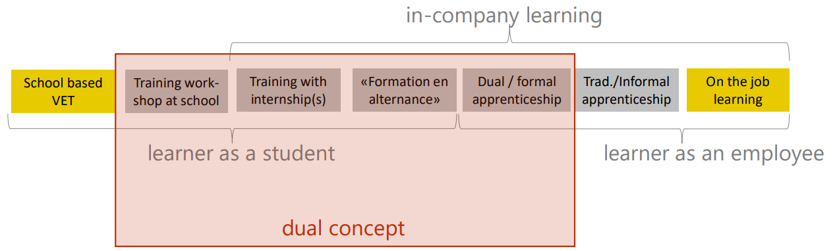

Given the development of the private sector and the remote location of the hotels in pilot regions (Zaamin and Bustanlik), the full dual and formal apprenticeship like delivered in Switzerland seems too far from what can be realistically applied in Uzbekistan at the moment. For a better acceptance of the new modalities, it is important to analyse and build on existing practices. This approach, from within the system, is the preferred option to facilitate institutionalisation and scaling up. In the hospitality sector, as well as for some other professions taught in colleges and technicums, it seems that **training with internship is a current practice and can range up to 28 weeks within curricula.**

We therefore recommend **moving to longer (ideal ratio of 50/50 between school and internship) and better structured internships with pioneering companies as models for a more organised business sector. VET4UZ would support the “dualization process” by improving current practices (OJT tools, internship contract and grading, clearly defined roles and responsibilities).**

For most of the hotel and destinations, the ideal period for internship is between May and September. This is during the summer holiday and the high season, guaranteeing enough customer flow for proper on-the-job training, return on investment for hotels and even relevant pocket money (e.g. service charge) for youth. Whereas it seems that an “employment contract” with payment and no grading/curricula is currently the norm for internships, VET4UZ should support the review of new internship regulations between hotels and schools.

Another option to be tested in parallel is the delivery of evening courses for professionals. Many training providers (University, technicums, colleges) declared offering evening classes with a good flow of student and a high demand. It is also confirmed by a high demand for short-term courses (e.g. room service or front office in Zaamin). However, **such dual concept rather aim at upskilling working professionals** and do not improve initial training that VET4UZ targets.

## Competency-based VET

VET4UZ started capacity building on **the understanding of developing situation-based curricula**. It is a step in the right direction as the skills gap analysis reveals that a major problem lies in curricula which are not job-related.

“Tourism” and “hotel management” are not “jobs” for entry-level professionals but represent a whole sector or a group of jobs. Supporting the revision of competency-based curricula would be in line with **the implementation of better structured internships including practical syllabi with learning objectives along hotel SOPs and evaluation forms that count in the overall grade to pass the year.** Here below is an example of evaluation form for OJT in hospitality. We can notice that the learning objectives are competencies and focus more on soft skills.

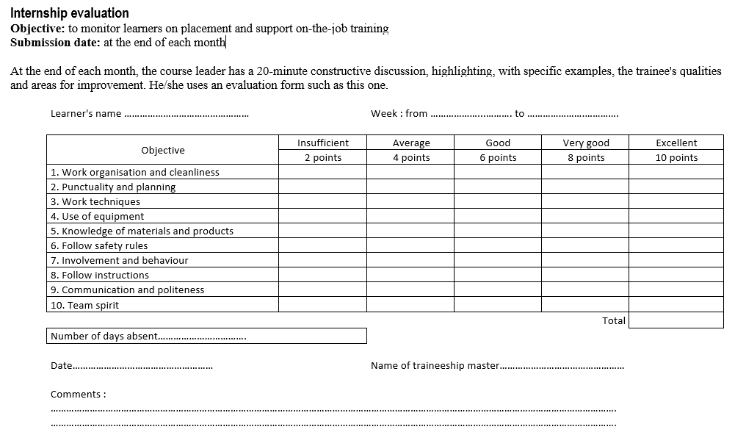

This revision could start with rooms division jobs (e.g. front office or housekeeping) as some work is currently initiated by the Ministry of Tourism and the hotel association. Another valid rationale would be to prioritize front of the house jobs (front office or F&B service) as they are generally more attractive for youth.

## Ways to engaged employers

A VET system belongs to the various stakeholders it serves. It is crucial that the employers feel involved and can effectively influence the system. VET4UZ can count on at least 9 partners hotels (at least 3 in each region) that the project must help to get organize and speak from a common voice. It is the right strategy to begin with few pro-active companies that can serve as champions for others. The number of hotels will then be increased with the time, once processes with these leaders have been tested and improved. Currently each institution visited has a person assigned for industry linkages. This person should be responsible for dialogue with employers.

The complementary measures described below are recommended to support the dialogue between employers and schools. They cannot replace the improvement of the system and the real dual VET concept, but, together they contribute to a more market-relevant training:

* **Visiting lecturers from the employers** (e.g. in low season): develop a mechanism together with hotels at regional level to have some of their key staff (e.g. housekeeping supervisor, front office employee, HR manager) coming to schools to explain hotel operation processes and what is expected from youth during internships;
* **Internships for teachers:** training quality would increase if school teachers would regularly spend few weeks or months on internship in hotels of the region to better understand the needs of employers at operational level;
* **Participation in exams (semester exams) and grading (during internships):** Although employers’ participation in exams and internships are already part of the training scheme, this is not applied nor effective in practice. Strengthening and structuring processes would increase interaction between schools and employers;
* **Review curricula**: schools apparently have margin to tailor their curriculum but do not take the initiative to do so in practice. Supporting joint workshops with the employers at local level would reduce the gap with private sector needs;
* **Creation of a small “career center”**: in each of the institution a focal person or place should advertise for internship and job opportunities. This would be supported by a “career day/fair” where employers would come to school to present their company and explain what they expect from the students.

*Cost-effectiveness of capacity building*

To foster the collaboration and ease the implementation of the measures above, we suggest VET4UZ **to support the creation of a small working group of employers in each region to facilitate exchange at local level and have one voice from the employers side**. Reunite training all hotels with training providers would also ease the capacity building.

Lessons learnt from similar projects shows there is a high risk to be dependent on one partner institutions or a small number of local experts. To mitigate this menace, we propose to train a pool of 15-20 Master Instructors (MI) with a mix of locally working professionals, training consultants and trainers with relevant hospitality experience. The key criterion is to have at least 10 years of experience, including at middle-management level. **Following a cascading model, these MIs will be trained by a core group of selected hospitality experts** (e.g. EHL or other national or international hospitality experts) who will be in charge of the yearly training update and quality control. The MIs will also be capacitated for organizational development and receive a Swiss/international certification. **In a second stage MIs will train hospitality middle-managers from the different department in order for them to deliver quality OJT to students on internship.**

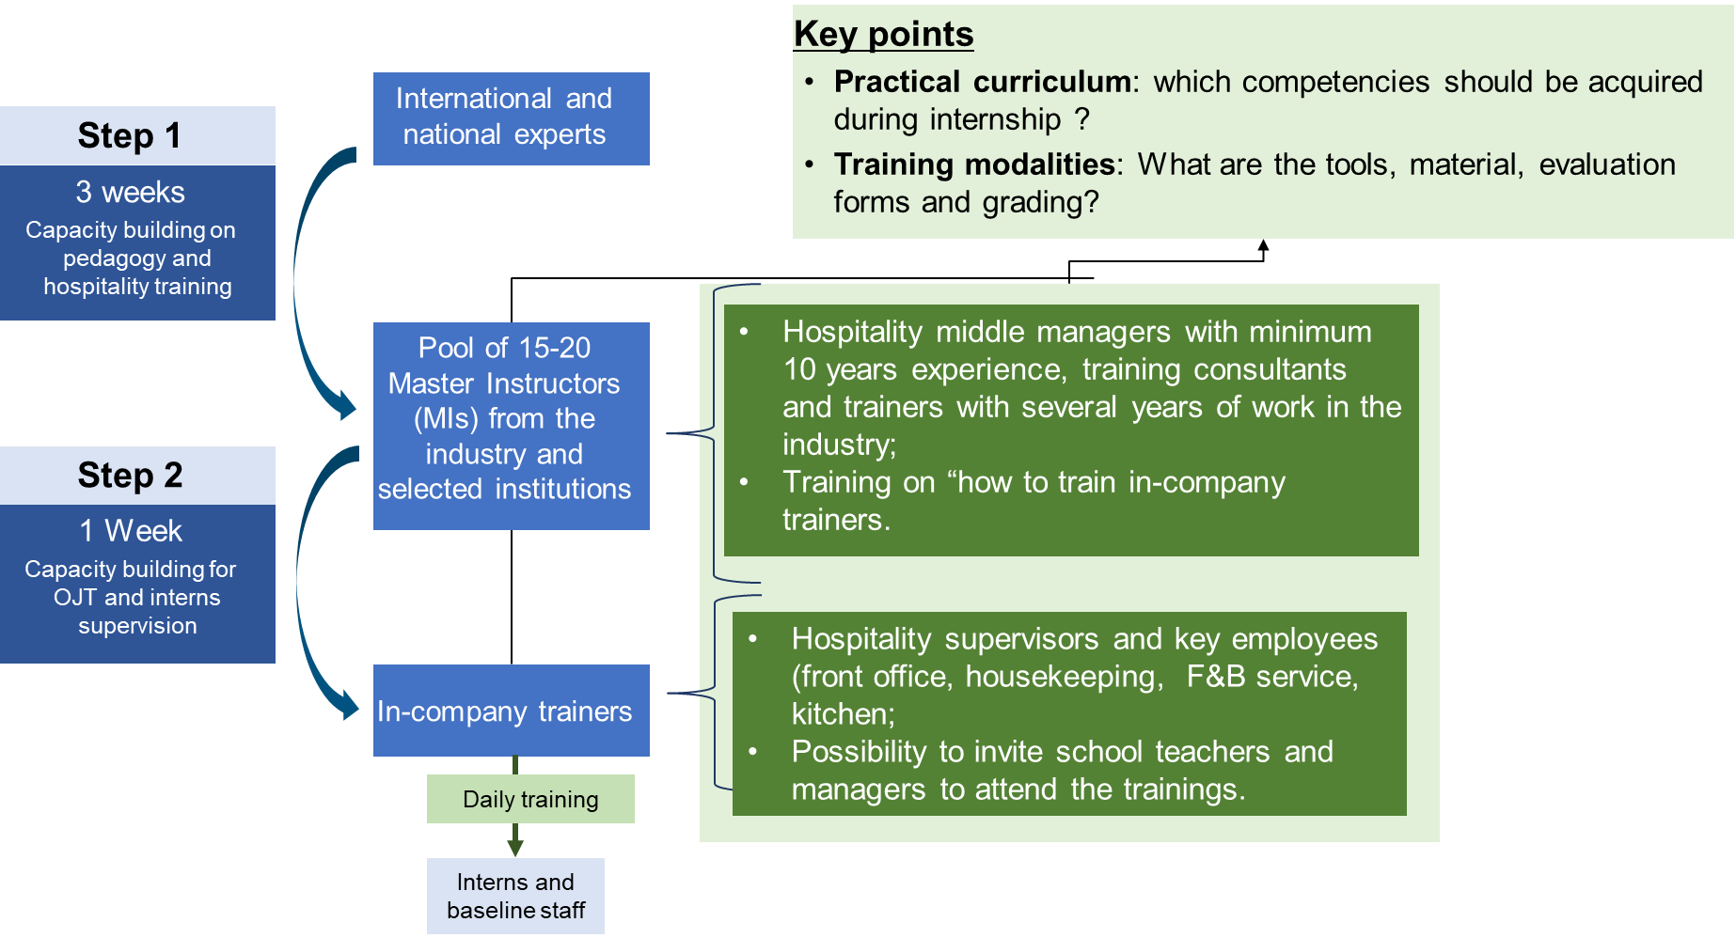

The previous experiences with this model (e.g. Bhutan[3], Laos[4], Myanmar[5]) revealed that this design with local tandems was particularly useful during the pandemic, stimulated innovation and development of the programme.

*Focus on middle-management: a cascading effect if properly equipped*

As many middle-management hospitality professional have pursued alternative pathways as a consequence of the pandemic we see the need to focus on this level (F&B manager, Front Office supervisors, Kitchen head, Housekeeping manager …). As middle-manager generally supervise about 10 staff in their position, concentrating training efforts on this intermediary level is, in our view, the best way to improve hospitality excellence, transfer Swiss know-how and provide a cost-effective response by reaching a high number of youth and employees.

Hospitality line staff learn much better, if training takes place in real work situations to which the participants can relate to. Middle-managers will be provided with the appropriate tools to deliver basic training to interns and their own staff, hence having a trickle-down effect and bringing important benefits for the participating hotels. A complement could be to have accessible training material at low cost for line staff with a priority focus on digitalization. For instance, EHL offers a fully online VET by EHL’s Learning Management System[6] that could be made accessible for hotels partnering with and contributing to the training.

Follow up / action plan

Depending on priorities of the project and buy-in of the local stakeholders, VET4UZ project could conduct the following activities throughout phase I:

1. support the **establishment of an employer Working Groups in each of the region** that would meet periodically (e.g. every quarter) to exchange on industry needs and share best practices for on-the-job training ;
2. organize a workshop with school representative in each region to **define the collaboration (cf. further above Ways to engage employers)** with the employers through a convention (needs, contributions, working modalities, processes). Assign focal persons from employers and school sides for coordination and regular communication;
3. support employers working group, together with the school representative, in **defining framework conditions and terms for internships** including duration, timeframe, working hours and conditions, gradual payment scheme, basic internship contract;
4. support colleges, together with employers working group, to **structure the pedagogical part of the internships** including practical syllabi, learning objectives, evaluation forms, grading;
5. support the **capacity building of in-company supervisors** (internship focal persons who will train, coach and evaluate interns). First by training a pool (10-20) of Master instructors at national level who will be in charge of replicating the training through regions in a cascading model. They will equip (training materials, pedagogical training, constructive feedback, evaluation tools, SOPs,) in-company supervisors;
6. **Pilot improved internship system** supported by a dialogue between the college industry relation officer and the working group (single focal point);
7. Introduce **feedback system** between schools and employer Working Groups to improve the collaboration.

*Below: Pictures of the field visits and interviews*

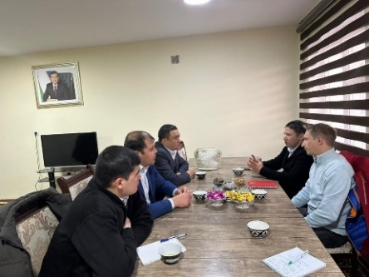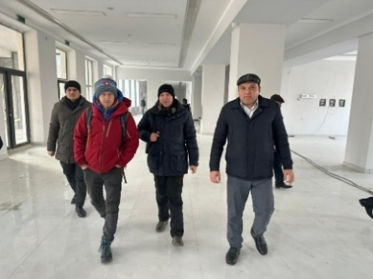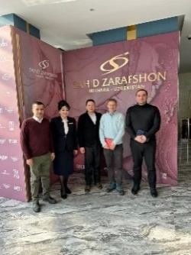

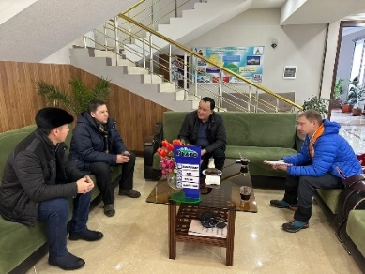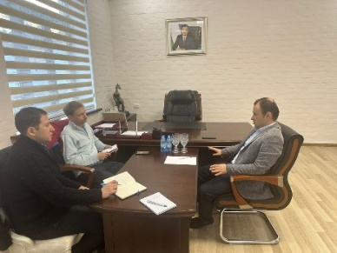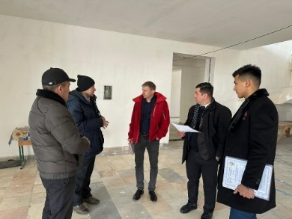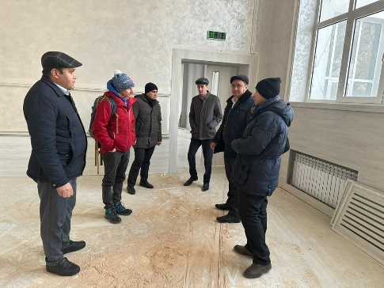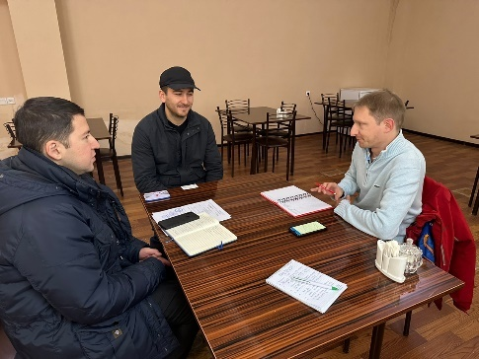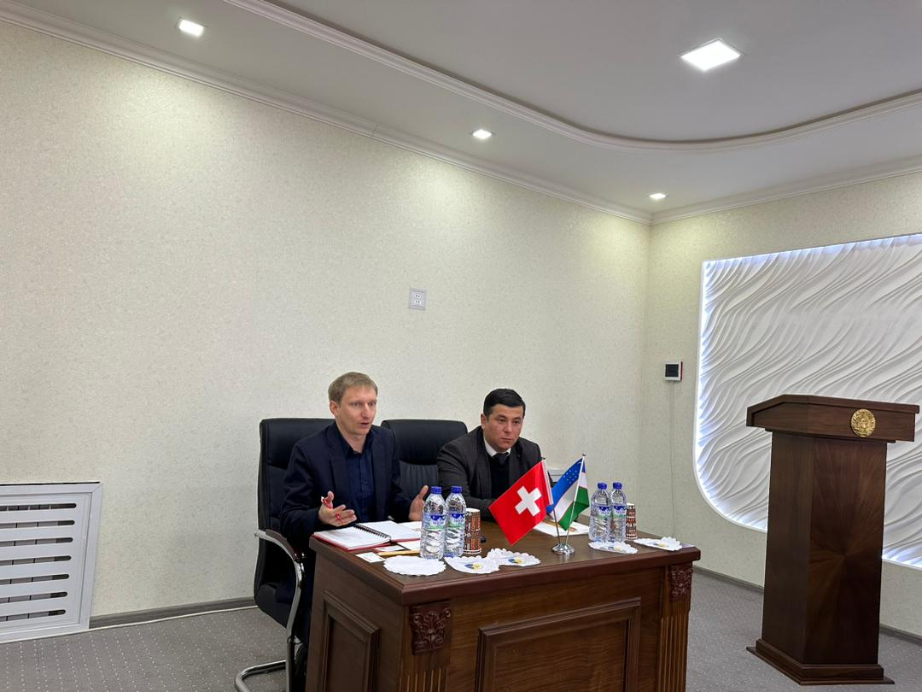

Annexes

## Annexe 1 - Study program per VET provider

according to the qualification with the split of theory and practice hours.

The devoted weeks in each pilot VET providers vary as in the lines below:

### Bustanlik college of tourism and service

|  |  |  |  |
| --- | --- | --- | --- |
| **Secondary-special professional education**  **name of the specialty at the level:** | **Qualification:** | **Duration of study** | **Form of education** |
| 41010401 -   Hotel management and organization. | 1. Hotel administrator. | 1 year 3 months | Full time |

|  |  |  |  |  |  |  |  |  |  |  |  |  |  |  |  |  |  |  |  |  |  |  |  |  |  |  |  |  |
| --- | --- | --- | --- | --- | --- | --- | --- | --- | --- | --- | --- | --- | --- | --- | --- | --- | --- | --- | --- | --- | --- | --- | --- | --- | --- | --- | --- | --- |
|  | **Name of block** | | | | | **Amount of credits** | | | | | | | | **Auditorium training load, hours** | | | | **%** | | **Number of weeks** | | | | | **Months** | | |  |
| 1 | General and special subjects | | | | | 30 | | | | | | | | 764 | | | | 41 | | 21 | | | | | 5 | | |  |
| 2 | Educational practice | | | | | 15 | | | | | | | | 390 | | | | 21 | | 10 | | | | | 3 | | |  |
| 3 | Production and pre-diploma practice | | | | | 25 | | | | | | | | 648 | | | | 35 | | 18 | | | | | 5 | | |  |
| 4 | State certification | | | | | 3 | | | | | | | | 48 | | | | 3 | | 2 | | | | | 0 | | |  |
|  | **Total:** | | | | | **73** | | | | | | | | **1850** | | | | **100** | | **51** | | | | | **13** | | |  |
|  |  |  |  |  |  | |  |  |  |  |  |  |  | |  |  |  | |  | |  |  |  |  | |  |  | | |  |

### Zaamin college of tourism and service

|  |  |  |  |
| --- | --- | --- | --- |
| **Secondary-special professional education**  **name of the specialty at the level:** | **Qualification:** | **Duration of study** | **Form of education** |
| 41010401 -   Hotel management and organization. | 1. Hotel administrator.  2. Room fund supervisor | 2 years | Full time |

|  |  |  |  |  |  |  |  |  |  |  |  |  |  |  |  |  |  |  |  |  |  |
| --- | --- | --- | --- | --- | --- | --- | --- | --- | --- | --- | --- | --- | --- | --- | --- | --- | --- | --- | --- | --- | --- |
|  | **Name of block** | | | | | | **Auditorium training load, hours** | | | **%** | | | | **Number of weeks** | | | | **Months** | | | |
| 1 | General and special subjects | | | | | | 864 | | | 30 | | | | 33 | | | | 7 | | | |
| 2 | Educational practice | | | | | | 660 | | | 23 | | | | 29 | | | | 5 | | | |
| 3 | Production and pre-diploma practice | | | | | | 1296 | | | 45 | | | | 11 | | | | 5 | | | |
| 4 | State certification | | | | | | 60 | | | 2 | | | | 2 | | | | 3 | | | |
|  | **Total:** | | | | | | **2880** | | | **100** | | | | **75** | | | | **20** | | | |
|  |  |  |  |  |  |  |  |  |  |  |  |  |  | |  |  |  | |  |  |

### Bukhara Technikum of Tourism and Cultural Heritage

|  |  |  |  |
| --- | --- | --- | --- |
| **Secondary-special professional education**  **name of the specialty at the level:** | **Qualification:** | **Duration of study** | **Form of education** |
| 51010401 -   Hotel management and organization. | 1.  Manager of administrative and economic service.  2. Food & Beverage Manager | 2 years | Full time |

|  |  |  |  |  |  |  |  |  |  |  |  |  |  |  |  |  |  |  |  |  |  |  |  |  |  |  |  |  |  |  |  |  |  |
| --- | --- | --- | --- | --- | --- | --- | --- | --- | --- | --- | --- | --- | --- | --- | --- | --- | --- | --- | --- | --- | --- | --- | --- | --- | --- | --- | --- | --- | --- | --- | --- | --- | --- |
|  | | **Name of block** | | | | | | | | | | | **Amount of credits** | | | **Auditorium training load, hours** | | | | | **%** | | | | | **Number of weeks** | | | | | **Months** |  | |
| 1 | | Natural and humanities | | | | | | | | | | | 36 | | | 872 | | | | | 30 | | | | | 24 | | | | | 6 |  | |
| 2 | | Specialty sciences | | | | | | | | | | | 30 | | | 724 | | | | | 25 | | | | | 20 | | | | | 5 |  | |
| 3 | | Educational practice | | | | | | | | | | | 16 | | | 384 | | | | | 13 | | | | | 11 | | | | | 3 |  | |
| 4 | | Production and pre-diploma practice | | | | | | | | | | | 35 | | | 840 | | | | | 29 | | | | | 23 | | | | | 6 |  | |
| 5 | | State certificate | | | | | | | | | | | 3 | | | 60 | | | | | 2 | | | | | 2 | | | | | 0 |  | |
|  | | **Total:** | | | | | | | | | | | **120** | | | **2880** | | | | | **100** | | | | | **80** | | | | | **20** |  | |
|  |  |  |  |  |  |  |  |  |  |  |  |  | |  |  | |  |  |  |  | |  |  |  |  | |  |  |  |  | | |  | |

## Annexe 3 – Meeting minutes of

Author: Asliddin Odilov

**Meeting with the management of Zamin College of Tourism and Regional department of tourism** (Zamin, Jizzakh)

**Date:** January 26, 2023

**Time:** 11:30 – 12:30

**Participants from the college:**   
Nodira Omonqulova – director the of the college,

Ganisher Tuymurodov – head of infstructure unit of regional department of tourism,

Nargiza Oqilova – specialist of regional department of tourism

**Participants from the project:**   
Adrien Rebold - Advisor Vocational Skills Development, Helvetas Swiss Intercooperation

Sardor Saidrasulov – Senior Expert on Private Sector Engagement, VET4UZ project

Asliddin Odilov – Senior Expert on Quality assurance, VET4UZ project

The college is not operational and in the reconstruction phase. 80% of remodeliing works are completed, the main building is being equipped with furniture and computers, the buildings assigned for conducting practical trainings (kitchen, hotel management and mountain climbing) are under construction.

The capacity of the college is 600 students. The quota for study programmes is not fixed and determined according to the needs of industry. The college services as single training institution for two regions: Jizzakh and Sirdarya.

Actually, there is a growing demand from the youth to study professions such as hotel administrator, middle management positions in hotels, cook and kitchen management.

Due to the construction of the college, the teaching process is organized in Zamin medical technikum and practical trainings are being conducted in hotels.

The College cooperates with three hotels: Plato, Everest and Sayqal. Since there is no hotels’ association, the college works with each hotel individually. The college studies the needs of hotels and realizes that skills related to language, receptionist and room services are needed by hotels.

The curriculum and study materials are obtained from Ministry of tourism (Institute of tourism development) and Ministry of higher educations, science and innovation. The college teachers develop extra study materials based on the needs of employers in the region. According to director of the college, these study materials are not enough to train students and the support from VET4UZ project to share Swiss partners’ training materials and to develop curriculum and training materials in line with Swiss experience would be very helpful.

The management of regional department shared their vision and plans on the development of tourism in the region. The winter tourism is getting popular in the last years although Zamin is used to be resort zone during summer time. Inflow of foreign tourists is increasing year by year. Tourists usually come to enjoy the nature, but there are ongoing activities to develop rural tourism, agro tourism and mountain tourism. The number of hotels reached to 10 and number of community based hotels exceed 85.

**Recommendations:**

1. Project can help to connect hotels and establish their association so that there will be coordinated and regular communication with hotels and the College.
2. Project can use EHL’s capacity to develop curriculum and training materials for the College

**Meeting with the management of Plato hotel** *(Zamin, Jizzakh)*

**Date:** January 26, 2023

**Time** 14:30 – 16:30

**Participants from hotel:**Murod – General Manager of the hotel

Timur – Front Desk Manager of the hotel

**Participants from the project:**Adrien Rebold - Advisor Vocational Skills Development, Helvetas Swiss Intercooperation

Sardor Saidrasulov – Senior Expert on Private Sector Engagement, VET4UZ project

Asliddin Odilov – Senior Expert on Quality assurance, VET4UZ project

The General Manager and Front desk manager of the hotel provided brief information about the hotel operations and its cooperation with Zamin College of Tourism.

The Hotel has 23 rooms and can accommodate up to 50 guests. The full-time staff of hotel varies with seasonal conditions: 12 workers in the off-season period and 25 workers in the high season period (May – September).

The Hotel faces challenges related to the shortage of well-qualified staff. It has started cooperating with Zamin College of Tourism to train specialists. There is a high demand for specialists in kitchen, housekeeping, room service, reception and medical treatment units.

The hotel has favorable working conditions for students: they get paid during internship period, provided with accommodation and food, students may get full salary if they can replace the staff of hotel. Last year the hotel accepted student interns for the first time after reopening. However, those students didn’t stay for a full-time employment due to the distance problem (distance between the college and hotel is 50 km).

According to General Manager, communication, hygiene and attitude skills are the most important skills needed from students. Hard skills (technical skills) are also important, but students can gain these skills during on-the-job training.

The hotel doesn’t have training manuals and SOPs to conduct on-the-job training.

The hotel cooperates with other hotels in the region (mostly with Sayqal and Everest) informally in the areas of exchange/sharing of guests and staff.

CONCLUSIONS:

1. The hotel has enough capacity and strong motivation to provide training to the students of the college;

2. The VET4UZ project can support the hotel and other hotels in the region in the training of students and cooperation with the College through connecting hotels and establishing Working Group so that there will be coordinated and regular communication between hotels and the College;

3. Support hotel supervisors in conducting on-the-job training (training materials, SOPs);

4. Introduce a feedback system between the College and the Hotel on the performance of interns and develop the capacity of hotel supervisors in providing on-the-job training.

**Meeting with the management of Everest Hotel**

**Date:** January 27, 2023

**Time:** 10:00 – 12:00

**Participants from the college:**   
XXX – General Manager of the Hotel

**Participants from the project:**   
Adrien Rebold - Advisor Vocational Skills Development, Helvetas Swiss Intercooperation

Sardor Saidrasulov – Senior Expert on Private Sector Engagement, VET4UZ project

Asliddin Odilov – Senior Expert on Quality assurance, VET4UZ project

The hotel is operating since November 2021 (1 year 3 months). It has 63 rooms, and 2 restaurants. Mostly Uzbek tourists stay at the hotel, but there is also growing inflow of Russian and foreign tourists from neighboring countries.

The hotel employs 55-60 people during the high season period and about 25 people in off-season period.

High seasonality of employment is a major issue. For this reason, the hotel has a great interest and motivation to cooperate with Zamin College of Tourism in training the youth at Front office, F&B, kitchen and room service.

The hotel has capacity to provide training up to 10 interns (2 intern per department). It can provide food and accommodation, even small amount of salary enough for pocket expenses. The training is usually organized in the following way: Day 1 - general training to all interns; From Day 2 – interns are distributed to different units with Supervisors.

However, there is low motivation among the youth to gain skills and to learn more during internships. According to the general manager, the youth interns are not eager to learn new things and to engage different activities in the hotel to gain skills, they just come to spend the time.

The hotel was able to hire one of interns to full-time position (mountain guide). The rest of interns didn’t want to work at the hotel. There is also high need for female workers in housekeeping, laundry and restaurant, but due to cultural matters girls don’t come to hotel to work or don’t work for longer period of time.

The general manager has expressed his willingness to send his experienced staff to the college to train students.

**Recommendations**:

* Support hotels in negotiating conditions and terms for internship. It would be great to develop a standard payment scheme for interns (no payment first two weeks + 30% of full salary + full salary if an intern is able to substitute the staff completely);
* Support hotel supervisors in conducting on-the-job training (training materials, SOPs);
* Introduce feedback system between College and Hotel on the performance of interns and develop capacity of hotel supervisors in providing constructive feedback to a student and college;
* Support VET providers in engaging hotel staff in teaching and training.

**Meeting with the management of Sayqal Zamin Hotel**

**Date:** January 27, 2023

**Time:** 13:30 – 14:30

**Participants from the hotel:**   
Shohjahon – General Manager of the Hotel

**Participants from the project:**   
Adrien Rebold - Advisor Vocational Skills Development, Helvetas Swiss Intercooperation

Sardor Saidrasulov – Senior Expert on Private Sector Engagement, VET4UZ project

Asliddin Odilov – Senior Expert on Quality assurance, VET4UZ project

Two hotels in Zamin are run under Sayqal brand: Hotel Sayqal and Hotel Sayqal Zamin.

These hotels have 36 rooms in total: 20 rooms in Sayqal and 16 rooms in Sayqal Zamin. Number of permanent (core) staff of each hotel is about 6-8 people. But each hotel employs up to 20 people during a high season period.

According to General Manager, there is a high demand for the staff in reception and room service units. Language and communication skills as well as attitude of the youth are very important in hiring them. Technical skills can be gained during on-the-job training provided by the hotel.

Hotel usually accepts college students for internship. Two hotels can train up to 30 interns or 15 interns in each hotel.

However, there is low motivation among the youth to gain skills and to learn more during internships. According to the general manager, the youth interns are not eager to learn new things and to engage different activities in the hotel to gain skills, they just come to spend the time.

The general manager is highly motivated to improve the quality of training in the college and to train students during summer time period which is a high season period for tourism, but only those students who are highly motivated to be trained.

**Recommendations**:

* Support hotels in negotiating conditions and terms for internship. It would be great to develop a standard payment scheme for interns (no payment first two weeks + 30% of full salary + full salary if an intern is able to substitute the staff completely);
* Support hotel supervisors/staff in conducting on-the-job training (training materials, SOPs);
* Introduce feedback system between College and Hotel on the performance of interns and develop capacity of hotel supervisors in providing constructive feedback to a student and college;
* Support VET providers in engaging hotel staff in teaching and training.

**Meeting with the management of Bustanlik College of Tourism and Service** *(Soyliq village, Bustanlik, Tashkent)*

**Date:** January 30, 2023

**Time:** 11:00 – 13:00

**Participants from the hotel:**

Shukhrat Ilyasov – Director of the College

Bokhodir Mirahmedov – Deputy Director on Academic Affairs

Bakhtiyor Azmetov – Deputy Director on Work-based training

Maftuna Tajiddinova – Supervisor of Internships in Hotel Management

**Participants from the project:**   
Adrien Rebold - Advisor Vocational Skills Development, Helvetas Swiss Intercooperation

Sardor Saidrasulov – Senior Expert on Private Sector Engagement, VET4UZ project

Asliddin Odilov – Senior Expert on Quality assurance, VET4UZ project

The college is not operational and in the reconstruction phase (25% of remodeliing works are completed). The education process is organized temporarily at the professional school in the region.

The College management is considering PPP opportunities in expanding the services provided by the college. In particular, they are looking for a partner to build a dormitory with 50 beds that can used to provide hostel and restaurant services to the public along with student residence. In addition, there is an investor ready to invest in building facilities for horse riding activities in the unused territory of the college. The involvement of private sector is beneficial not only as the additional source of income, but also in terms of employment of students, training of students in live environment and to organize work-based learning.

The capacity of the college is 435 students, but 138 students study in the college today due to the remodeling of the facilities: first-year students – 87 and second-year students – 51. The college trains students in three areas: tourism (53 students), hotel management and organization (43 students) and Food services (42 students).

There are used to be total 12 teachers in the college, but three of them quit the job recently due to the better working conditions in the private sector. Teachers don’t have industry experience and it is difficult to attract people with industry experience in teaching due to the low salary. Teachers are engaged in capacity building activities organized by the Ministry (i.e. mandatory training every three years), but they usually don’t participate in workplace attachment trainings.

50% of the college graduates don’t work in the field they studied. The college director admitted that the main reason for that is the lack of proper skills of graduates needed by employers.

The college cooperates with 12 employers in the region: three of them are large hotels and the rest are family hotels. Cooperation with private sector is limited to the organization of internships: industry staff are not involved in teaching and conducting master classes, teachers are not trained in the industry.

Major challenges by the college are the lack of proper infrastructure to train students, keeping teachers due to low salary, weak cooperation with the industry and organization of internships for students.

**CONCLUSIONS:**

1. The College has a strong motivation to provide quality educational services to the youth, but the lack of proper infrastructure/human resources and support from main stakeholders (Ministry, employers) is not allowing to move forward;

2. The VET4UZ project can support the college in developing partnership with employers, in enhancing capacity of college staff on curriculum development and organizing work-based learning;

3. The VET4UZ project can support the college through sharing best practices in the world and among pilot colleges, establishing collaboration with pilot colleges;

4. The VET4UZ project can support the college through enhancing its capacity in providing students with employment services such as career guidance and job placement.

## Annexe 3 - Terms of Reference for internal consultancy

|  |  |
| --- | --- |
| N° of project/mandate: | 1253.01.20 |
| Part no. | 1253.0120.101.1200 |
| Project/mandate/country: | **Supporting VET Reforms in Uzbekistan Project (VET4UZ)** |

**Employer: HELVETAS Uzbekistan**

The Grand Business Center, office 506

12, Shota Rustaveli Street

100070 Tashkent, Uzbekistan

🕿 +998 91 004 41 43

e-mail gabriela.damian-timosenco@helvetas.org

|  |  |
| --- | --- |
| **Mandatory :** | Adrien Rebord  Education and Skills Development / Advisory Services |
| 🕿 | +41 76 500 93 45 |
| e-mail | [adrien.rebord@helvetas.org](mailto:adrien.rebord@helvetas.org) |

|  |  |  |  |  |
| --- | --- | --- | --- | --- |
| **Contract duration** | from: | **21 January 2023** | to: | **1 February 2023** |

1. **Basic information**

HELVETAS Uzbekistan (henceforth HELVETAS) implements a skills development project called Support to VET Reforms in Uzbekistan (VET4UZ). The main goal of VET4UZ (Phase 1, 2021-2025) is to contribute to more gainful employment of VET graduates through improved access to the labour market. This will be achieved through a systemic approach fostering improved coordination within the state structures as well as between the state and the economic actors and the improvement of quality of inputs (profiles, curricula, learning material, infrastructure, financing, management) into the VET offer. The project target is for the VET students, graduates and adults in Uzbekistan to profit from a functional labour market-oriented education and training system allowing them to find and retain an attractive and decent job in sectors with growth potential.

1. **Objectives**

The objectives of the consultancy are as follows:

1. Provide backstopping support to VET4UZ team on the project progress
2. Visit pilot VET providers in the pilot regions and identify capacity building needs
3. Establish opportunity to engage employers in the selected regions
4. **Key tasks**
5. Facilitate internal workshop with VET4UZ team
6. For each identified VET provider, conduct a small internal workshop with the school faculty
7. For each pilot region meet relevant local stakeholders and conduct an external workshop with employers on skills needs (hotels, restaurants…)
8. Summarize the diagnostics of the pilot regions from the VET providers and employers’ perspectives
9. **Expected results and deliverables**

The consultancy aims to provide the following results and deliverables:

1. A brief back to office report about VET4UZ progress that would include:
   1. A diagnostic of selected VET providers and suggestion to VET4UZ for capacity building.
   2. A skills gap analysis in the hospitality sector in the four pilot regions Tashkent (Bustanlik), Jizzakh (Zaamin), Bukhara and Samarkand to define employers needs and opportunities for engaging them in dual VET.
2. **Duration of contract**

The contract of this mission will last from 21 to 31 January 2023. The mission includes 1.5 days travelling (arrival from Bishkek) and 8 days of work in Uzbekistan.

1. **Mission programme**

**AGENDA OF ADRIEN’S REBORD MISSION TO UZBEKISTAN**

|  |  |  |
| --- | --- | --- |
| **Date** | **Programme** | **Accompanying staff of VET4UZ** |
| Sat, 21.01.23 | Arrival to Tashkent | Adrien Rebord |
| Mon, 23.01.23 | * 9.30 Meeting with the VET4UZ team at the project office: Discussion of activities and their implementation planned for 2023 * Exchange of experience, achievements and problems * Preparation for trips to pilot regions * 12.30 [Plov Lounge] Joint business lunch with the Ministry of Culture and Tourism of the Republic of Uzbekistan * 15:00 Meeting at the Association of Hoteliers of Uzbekistan | Adrien Rebord and VET4UZ team |
| Tue, 24.01.23 | * 07.20 - 08.30 Flight to Bukhara * 10.00 – 12.00 Meeting with Bukhara State University * 12.00 – 13.30 Lunch * 14.00-15.30 Meeting at Bukhara College of Tourism and Cultural Heritage | Adrien Rebord and VET4UZ team |
| * 15.50 – 17.25 Flight to Samarkand | Gabriela and Shukhrat Kamolov |
| Wed, 25.01.23 | * 10.00-12.00 Meeting at Saheed Zaravshan Hotel * 12.00-13.30 Meeting at the Turon Hotel * 13.30 – 15.00 Meeting with Turon City Plaza * 16.08-19.54 Train to Jizzakh | Adrien Rebord, Sardor Saidrasulov, Asliddin Odilov |
| * 11.00 Meeting with the International University of Tourism "Silk Road" in Samarkand | Gabriela and Shukhrat Kamolov |
| Thu, 26.01.23 | * Trip to Zaamin * 11.30 Meeting at Zaamin College of Tourism and Service * 13:00 Lunch * Trip to Zaamin mountain resort area * 15.00 – Meeting with Plato Hotel | Adrien Rebord, Sardor Saidrasulov, Asliddin Odilov |
| Fri, 27.01.23 | * 11.00-12.00 Meeting with Everest Plaza Hotel * 12:00 -13:00 Meeting with Sayqal Hotel * 13:30-14:20 Lunch * 14:20 Journey back to Jizzakh * 16.56-18.30 Train to Tashkent | Adrien Rebord, Sardor Saidrasulov, Asliddin Odilov |
| Mon, 30.01.23 | * Trip to Bostanlyk region * 11.30 – 13:00 Meeting with Bostanlyk College of Tourism and Service * Amirsoy (TBC meeting in Tashkent) * 16.00 Meeting with Humson Buloq Resort (Tashkent) | Adrien Rebord, Sardor Saidrasulov, Asliddin Odilov |
| Tue, 31.01.23 | * Discussion of the results of the visits to the pilot regions * Conclusions from the analysis of meetings with pilot colleges and skills gap analysis * Debriefing and planning next steps * Debriefing with the Embassy of Switzerland in Uzbekistan | Adrien Rebord and VET4UZ team |

1. **Reporting**

A brief mission report should be submitted in English by 15 March 2023 in electronic form to Gabriela Damian-Timosenco (GDT), VET4UZ Team Leader at [gabriela.damian-timosenco@helvetas.org](mailto:gabriela.damian-timosenco@helvetas.org).

Tashkent, 22 November 2022

1. <https://www.dcdualvet.org/wp-content/uploads/DCdVET_Mutual_Understanding_and_Principles_final.pdf>
2. <https://www.shareweb.ch/site/EI/Documents/VSD/Instruments/Slides%20Webinar%20on%20Dual%20VET%20(DCdVET).pdf>
3. https://www.facebook.com/groups/societyswissbhutan/permalink/2494808187232725/
4. Lanith Executive Management Training Program for the Tourism Sector, https://www.youtube.com/watch?v=0at6t47d7iU
5. https://www.swisscontact.org/_Resources/Persistent/b/4/7/8/b478c1d1b70cf5600578f43636d9d1f6bf9b4152/VSDP_Hospitality_Training_Factsheet.pdf
6. https://hospitalityinsights.ehl.edu/vet-ehl ; https://www.ehladvisory.com/facilitation-skills-online-training?hsCtaTracking=d94d1fdc-b0ae-411d-97a5-7fb3e787cce7%7Cfc204b71-1fce-4b7b-a973-d2049e1eb88b